LPE2504 CREATIVE WRITING SKILLS
SEMESTER 1 – 2025/2026
LECTURE NOTES 1 – WEEK 7

WEEK 7

IDIOM

Discussion
- What is your understanding of the term 'idiom'?

- Provide examples of idioms that you know of and their meaning.

- Why do you think people use idioms in conveying message?


Activity 1: Characteristic of Idioms
Compare the following lines and identify the characteristic of an idiom.

Expression | Idiom / Non-Idiom
It's raining cats and dogs.
The cat is sitting on the mat.
Break a leg!
The sun rises in the east.

From the table, what are the characteristics of an idiom?
- ______________________________________________________________
- ______________________________________________________________
- ______________________________________________________________

Activity 2: Guess the Idiom
Look at the following pictures and write the idiom and its meaning based on the illustrations.
No. | Clues | Idioms & Explanation
e.g. | 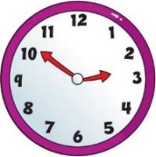  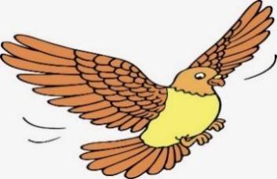 | Time flies  Time passes very quickly.
1. |   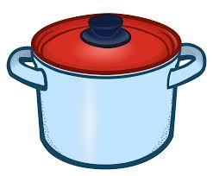
2. | 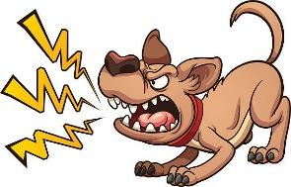    
3. |   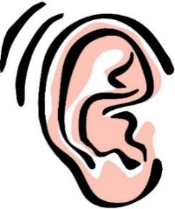
4. |     
5. |   
6. |     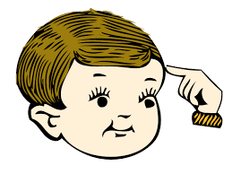
7. |   
8. |   
9. |     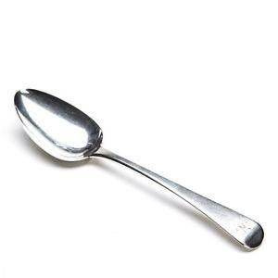
10. | 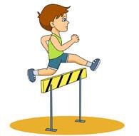  
11. | 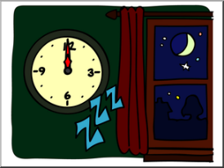    
12. |   
13. |   
14. | 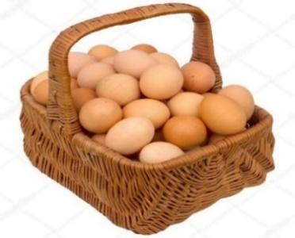
15. |     

Activity 3: Decipher the Idiom
Part A – Read the poem below with highlighted idioms below. Guess the meaning for each of the highlighted idioms.

Idioms

Lost in the shuffle, amidst the crowd's hum,
Echoes of silence, beating like a drum.
Life's a bitter pill, swallowed with a sigh,
Chasing shooting stars across the sky.

Painting the town red, in the dead of night,
Dancing on air, our hearts take flight.
Time heals all wounds, or so they say,
In the blink of an eye, we find our way.

by Anonymous

Idiom | Meaning
Lost in the shuffle

Life's a bitter pill

Painting the town red

Time heals all wounds

Part B – Choose 2 – 3 idioms from the poem in Part A and write a new 2- or 3-stanza poem containing the selected idioms without changing the meaning of the idiom.

Function of Idioms
Idioms serve several functions in poetry, enhancing the language and contributing to the overall artistic expression. Here are some functions of idioms in poetry:
- Conveying Cultural Nuances: Idioms often carry cultural or regional significance, providing insights into the traditions, beliefs, and unique expressions of a particular community. In poetry, they can enrich the cultural context and offer a deeper understanding of the setting.
- Enhancing Tone and Style: Idioms can influence the tone and style of a poem. Whether humorous, serious, or colloquial, the use of idioms can set the mood and evoke specific emotions. Poets leverage idioms to establish the desired atmosphere in their work.
- Playing with Language: Poetry often involves experimentation with language, and idioms provide poets with an opportunity to play with words and expressions creatively. They can be used for wordplay, puns, or unexpected twists, adding an element of surprise and delight for the reader.

Adapted from “Idioms” (n.d.). Literary Devices: Definition and Examples of Literary Terms at https://literarydevices.net/

Activity 4: Let’s Write
Choose one of the following themes or a theme of your own. Expand the theme by writing a four-line two-stanza poem using suitable idioms. You may add other suitable literary devices that you have learnt previously.

- Humour

- Nature

- Love

- Life

- Friendship

Chosen Theme: ___________________

________________________________________________________________________________________________________________________________
________________________________________________________________________________________________________________________________
________________________________________________________________________________________________________________________________
________________________________________________________________________________________________________________________________________________________________________________________________


Summary
Idioms, figurative expressions that convey meanings beyond their literal interpretation, play a pivotal role in enriching language and enhancing literary works.
In poetry, idioms serve multiple functions, serving as cultural signifiers that provide insights into the beliefs and traditions of a community. They contribute to the creation of vivid imagery, infusing poems with metaphorical richness and add depth to language, allowing poets to convey nuanced emotions and ideas in a concise and evocative manner.
Idioms also influence the tone and style of poetry, contributing to its unique atmosphere and providing opportunities for creative wordplay and experimentation.
